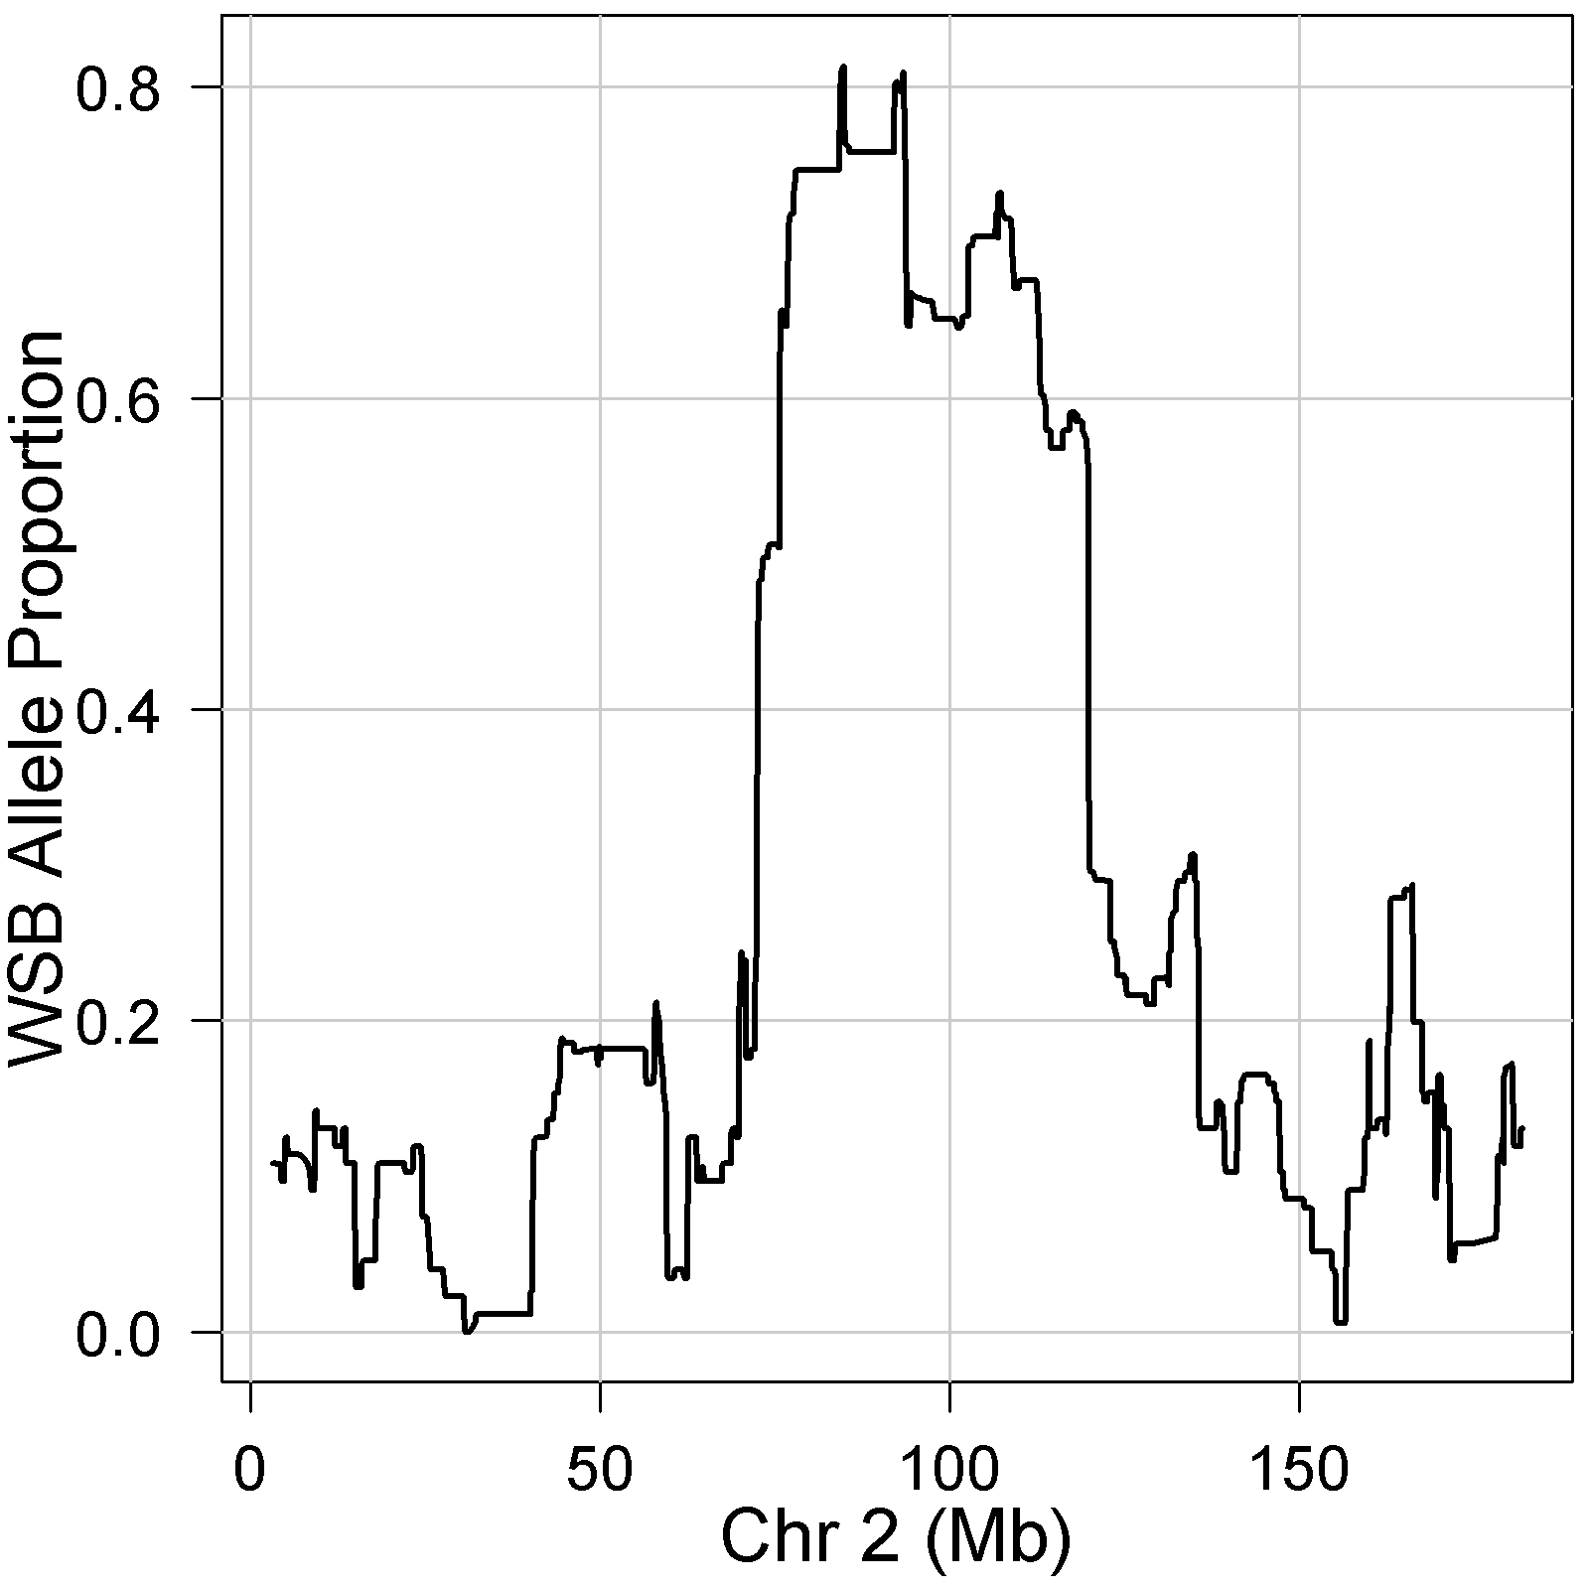

**Figure S1**. WSB/EiJ allele frequency in the HS-CC at generation 25 shows a peak at the *R2d2* locus.

MLG-ADELMA:Users:garyc:GARY:Projects:DO_Breeding:JDO_Breeding_Data:Analysis:DO_Productivity.pdf

**Figure S2. Proportion of matings that failed to produce a litter in the DO breeding colony across generations.** The sharp increase at G13 and G14 corresponds to the start of the breeding intervention.